Scanning project

Image server strategy

# Purpose

Current process of storing physical vouchers is expensive. It requires much human labour for organizing vouchers in boxes, transporting boxes to external box storage. It takes much human labour and time while searching vouchers in boxes. Vouchers are not secured and may be lost.

# Organization

Image server is organized as file server with consecutive (chain) input and parallel output.

# Image server description

It’s built from short file store, long file store, and external backup service provider.

# Short file store

Contains files for current year. It’s archived locally by symmetric save, delete, and update operations in two equal drives.

# Long file store

It contains images of vouchers from previous years. It’s archived once a year with external backup service provider.

# External backup service provider

It‘s eexternal company that provides data backup services. It backup long file store once a year. Archive type is snapshot.

# Sample server components

# Short file store

Two drives

**Seagate 4 TB External hard drive USB 3.0 Black -** £**100, available** [**here**](http://www.argos.co.uk/static/Product/partNumber/2388421.htm?CMPID=GS001&_$ja=cgid:12504949730|tsid:59158|cid:200290250|lid:94813864850|nw:g|crid:42772542890|rnd:16726280945801600997|dvc:c|adp:1o1|bku:1)**.**

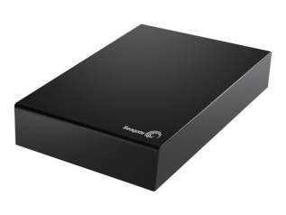

## Long file store

One drive

**Synology DS1813+ DiskStation 8-Bay 40TB Network Attached NAS Storage w/ 8x 5TB Seagate Enterprise Hard Drive - £3,264.96, available** [**here**](http://www.broadbandbuyer.co.uk/products/18674-synology-ds1813-plus-40tb-sge/)

[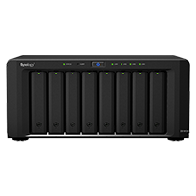](http://www.broadbandbuyer.co.uk/images/products/Synology/DS1813-plus-1.JPG)

## Data flow

## Create/Delete/Update operations

System create/delete/update files in short image store only, simultaneously on both drives.

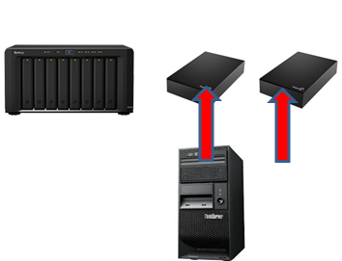

## Read operations

Depending on query date system read one drive of short file store or the drive of long file store

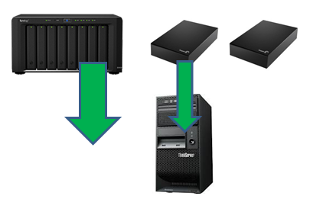

## Archiving data

Once a year system transfer data from short file store to long file store, delete outdated files in long file store and archive long file store to external backup provider. The type of archive is snapshot.

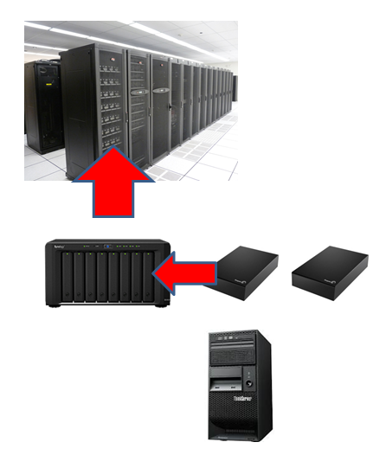

## Failure recovery operations

The drives of short file store are recoverable one from another. The drive of long file store is recordable from external backup service provider.

## 

## Folder herarhy

Folder herarhy is as follows YEAR -> COUNTRYID -> RETAILERID -> VOUCHERID.

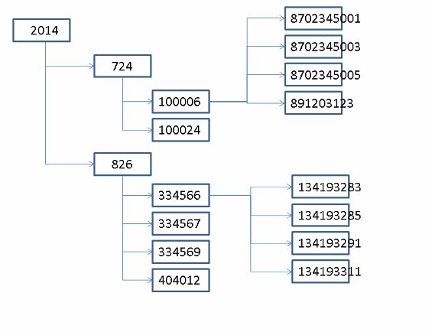

## Fault recovery times

## Short file store

Short file store is bould to voucher data entry process therefore in order not to stop the proces fault recovery should be very quick. It‘s matter of changing malfunctioning device and restart. System will recover the new drive during its work. In minutes it could be considered as 20 minutes.

## Long file store

During normal work long file store is a read only device. It‘s used for showing vouchers. Recovering the drive of long file store may take more time. It depends on external company that provides backup service. It may be considered as 1 day.